LAB 6
CLOUD COMPUTING:

Linux Users, Groups, Permissions, Pipes, and Bash Scripting
Name: Arshia Jadoon
Reg-no:BSE-2023-014
Semester-VA

Task 1 – Switch to root with su - and back to a normal user
task1_set_root_password.png
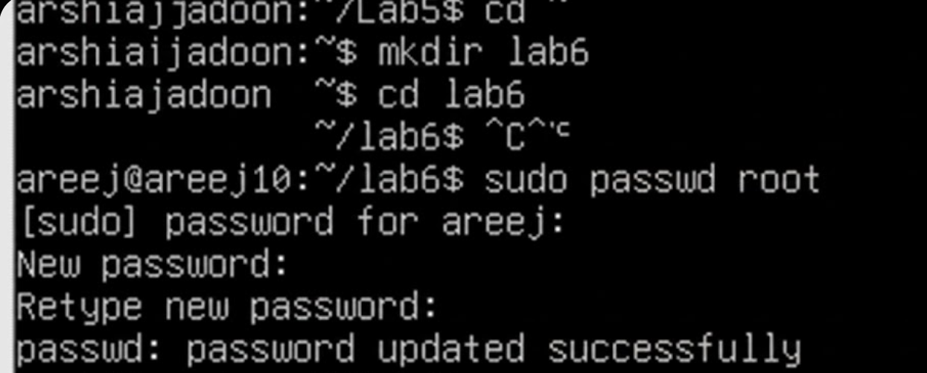
task1_su_root.png
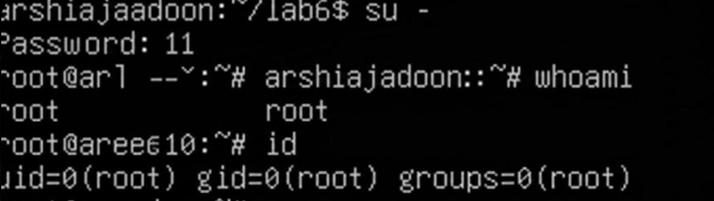
task1_exit_to_user.png
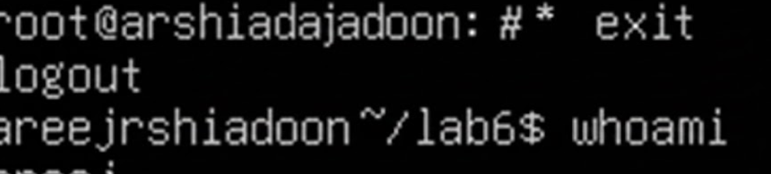

Task 2 – Create user tom and verify in passwd/group/shadow
task2_adduser_tom.png
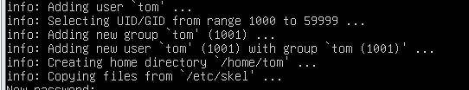
task2_verify_passwd.png
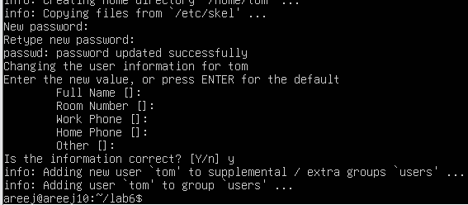
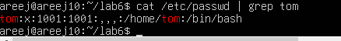
task2_verify_shadow.png

TASK 3: Create groups; change tom’s primary and secondary groups
task3_groupadd.png
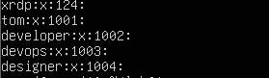
task3_change_primary_group.png
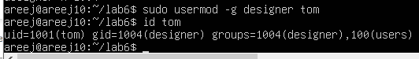
task3_add_secondary_groups.png
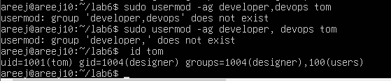

task3_reset_secondary_groups.png
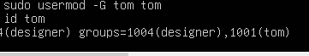

Task 4 – Create/delete users (Jerry, Scooby) and groups (jolly, anime)
task4_add_users.png
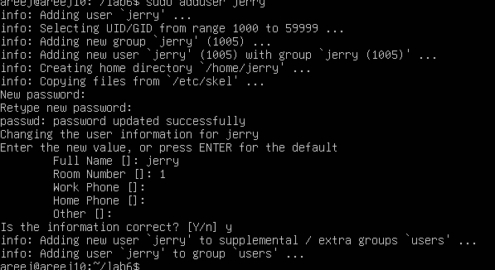
task4_scooby_su_auth_failure.png
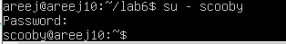
task4_set_password_scooby.png
task4_scooby_su_no_home.png
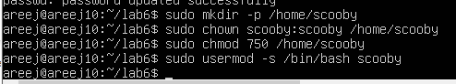
task4_scooby_no_home.png
task4_scooby_create_home.png
task4_scooby_login_success.png
task4_verify_users.png
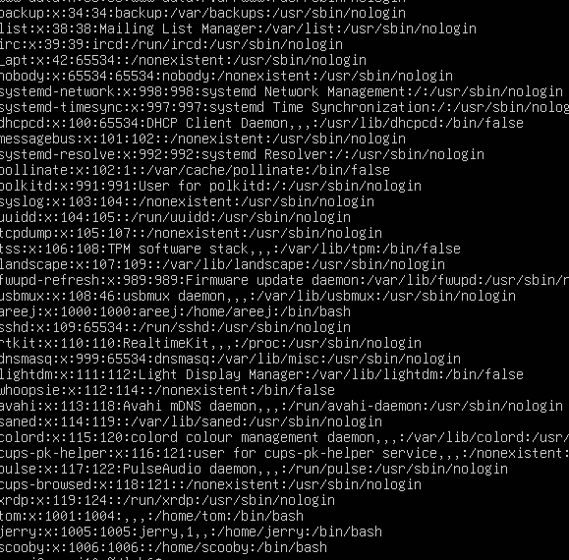
task4_shell_switching.png
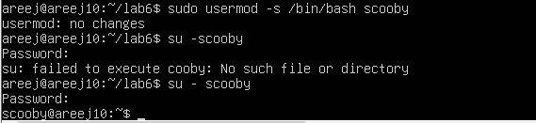
task4_add_groups.png
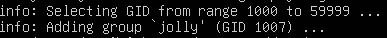
task4_verify_groups.png
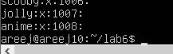
task4_delete_groups.png
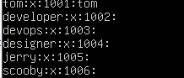
task4_delete_users.png
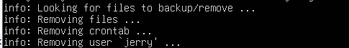

TASK 5: Create user Student; create files; set owner/group; identify file types
task5_create_student.png
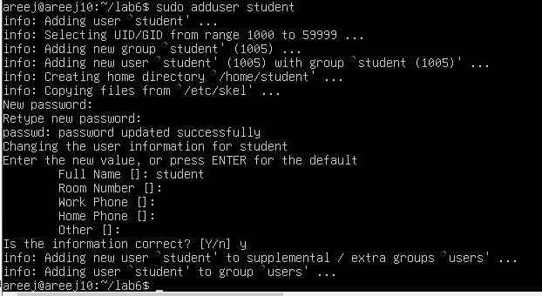
task5_create_files.png
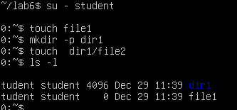
task5_chown_file1.png
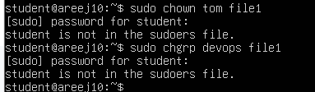
task5_chgrp_file1.png
task5_file_types.png
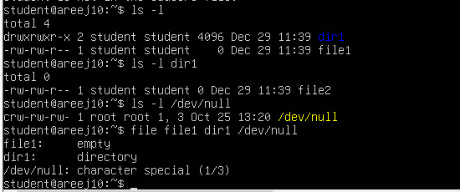
task5_exit_student.png
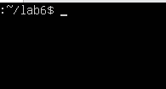

TASK 6: Change permissions using symbolic mode
task6_su_student.png
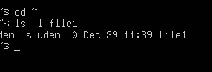
task6_chmod_remove_rwx.png
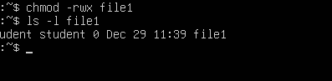
task6_chmod_add_r.png
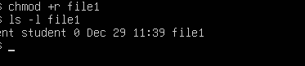
task6_chmod_u_plus_x.png
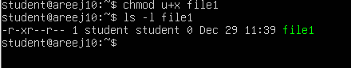
task6_chmod_ug_plus_w.png
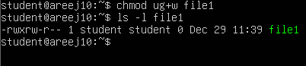
task6_chmod_ugo_minus_rwx.png
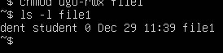

TASK 7: Change permissions using “set” symbolic form (u= g= o=)
task7_student_context.png
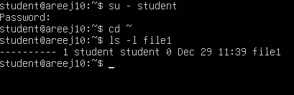
task7_chmod_set_all_rwx.png
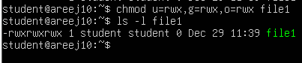
task7_remove_exec_go.png
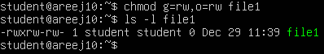
task7_remove_all_perms.png
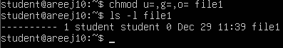

TASK 8: Change permissions using numeric (octal) mode
task8_chmod_777.png
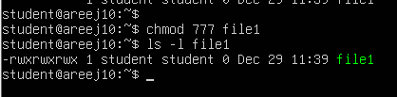
task8_chmod_700.png
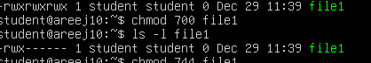
task8_chmod_744.png
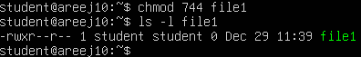
task8_chmod_640.png
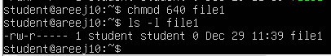
task8_chmod_664.png
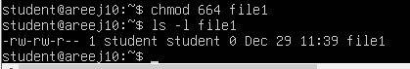
task8_chmod_775.png
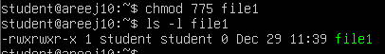
task8_chmod_750.png
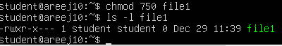

TASK 9: – Practice pipes, pagers, grep, and redirects with /var/log/syslog
task9_grep_less.png
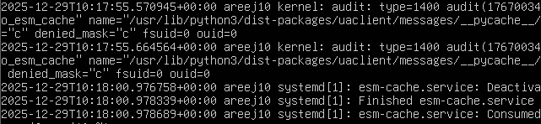
task9_grep_more.png
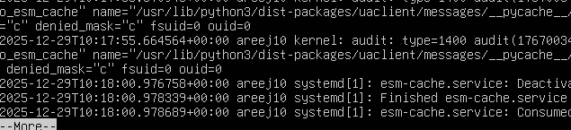
task9_grep_head.png
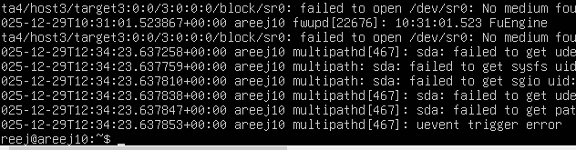
task9_redirect_overwrite.png
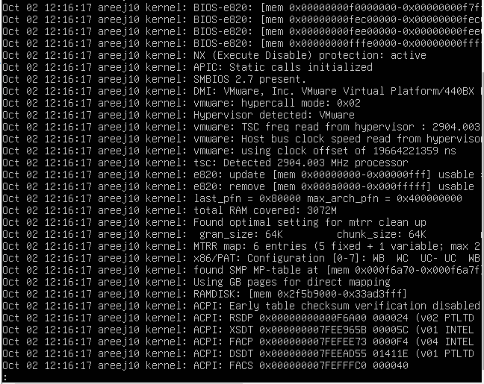
task9_journalctl_alternative.png

TASK 10: Script setup.sh – variables, command substitution, file/dir checks, permissions (use vim
task10_b1_vim.png
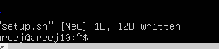
task10_b1_run.png
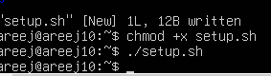
task10_b2_vim.png
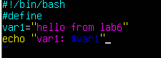
task10_b2_run.png
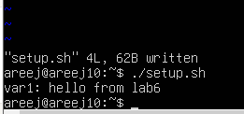
task10_b3_vim.png
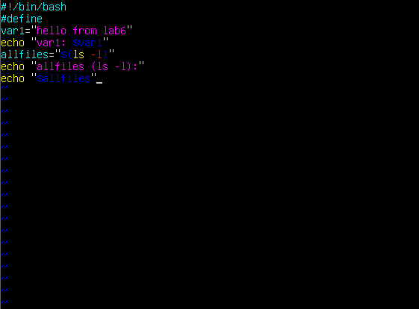
task10_b3_run.png
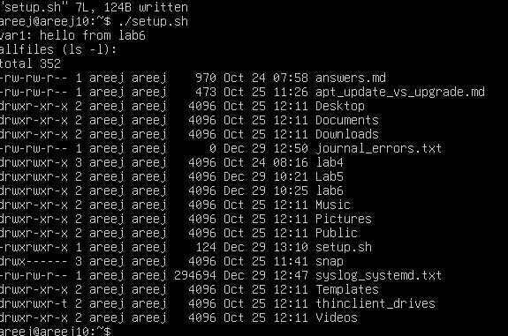
task10_b4_vim.png
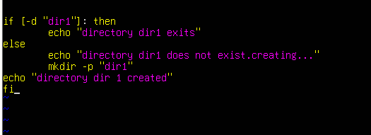
task10_b4_run.png
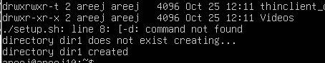
task10_b5_vim.png
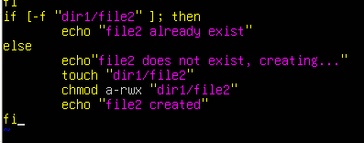
task10_b5_run.png
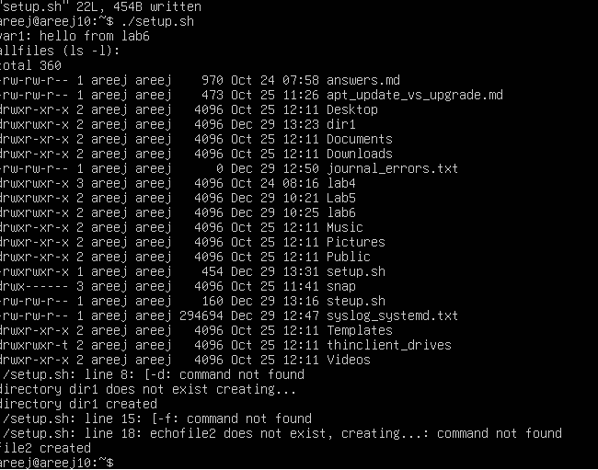
task10_b6_vim.png
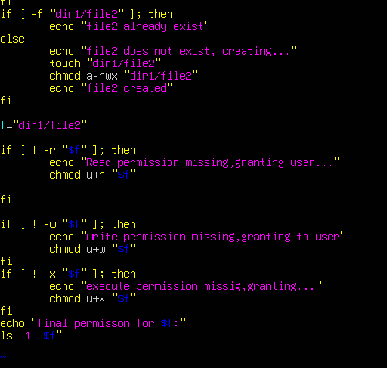
task10_b6_run.png
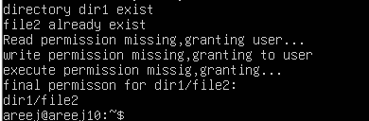

TASK11: Script setup.sh – argument comparisons (eq, ne, gt, lt, ge, le) and string checks
task11_b0_vim.png
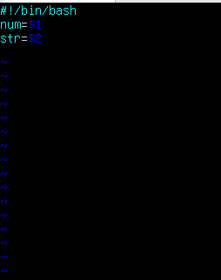
task11_b0_run.png
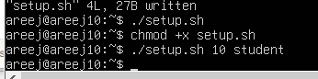
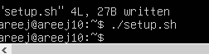
task11_b1_vim.png
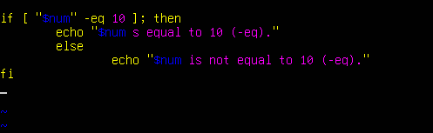

task11_b1_run.png
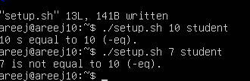
task11_b2_vim.png
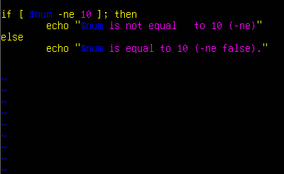
task11_b2_run.png
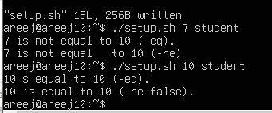
task11_b3_vim.png
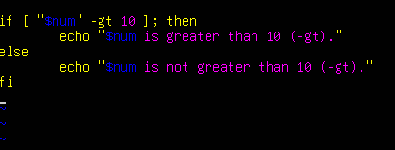
task11_b3_run.png
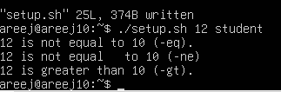
task11_b4_vim.png
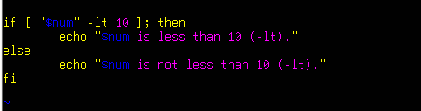
task11_b4_run.png
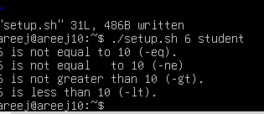
task11_b7_vim.png
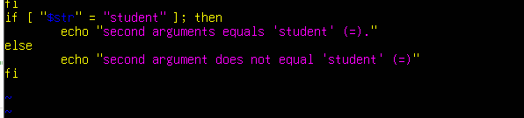
task11_b7_run.png
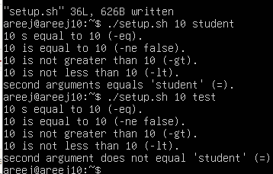
task11_b8_vim.png
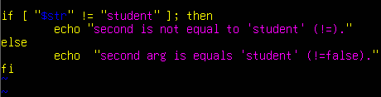
task11_b8_run.png
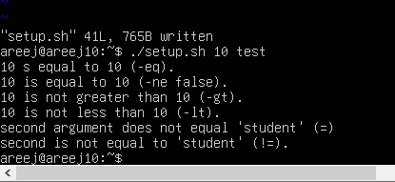

TASK 12: Script setup.sh – print all arguments with a for loop
task12_b1_vim.png
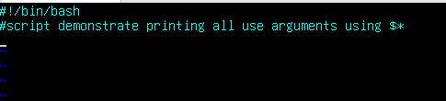
task12_b1_run.png
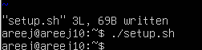
task12_b2_vim.png
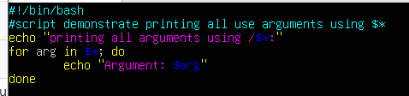
task12_b2_run.png
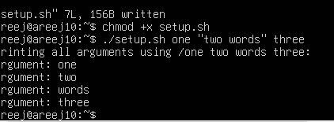

TASK 13: Script setup.sh – while loop summation and functions
task13_b1_vim.png
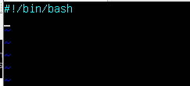
task13_b1_run.png
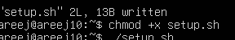
task13_b2_vim.png
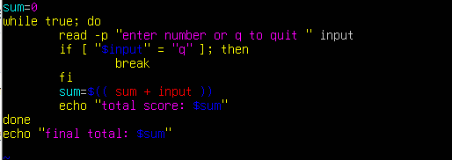
task13_b2_run.png
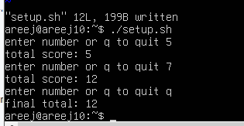
task13_b3_vim.png
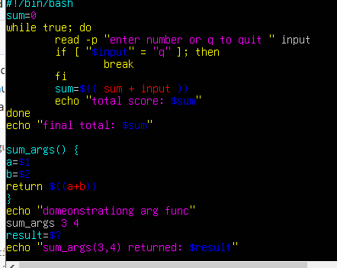
task13_b3_run.png
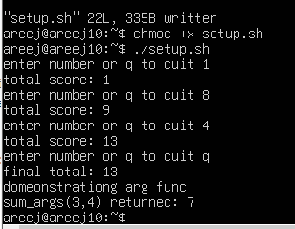

TASK 14
task14_fork.png
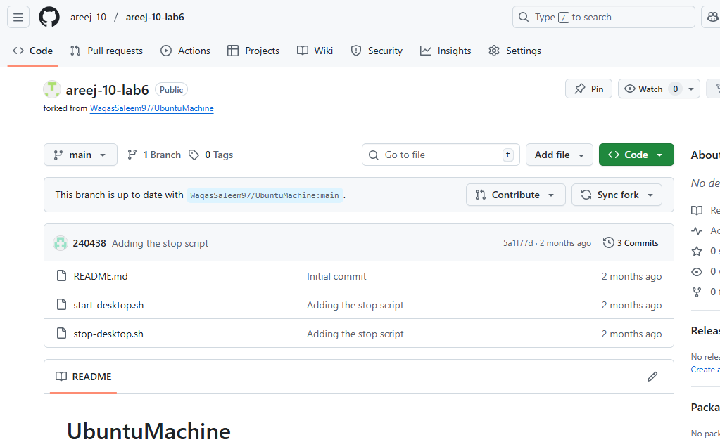
task14_codespace_launch.png
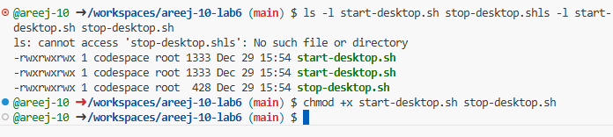
task14_start_script_ls.png
task14_start_run.png
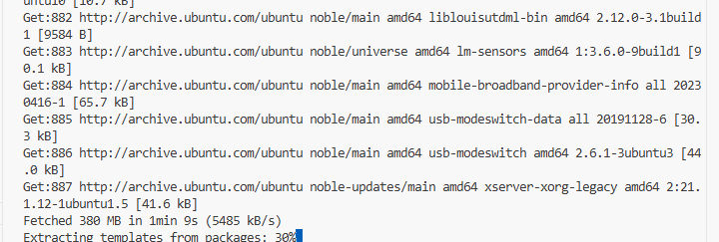
task14_ports_view.png
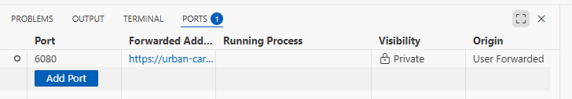
task14_vnc_url.png
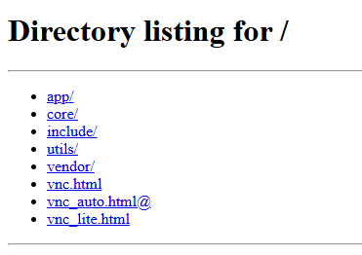
task14_vnc_password_prompt.png
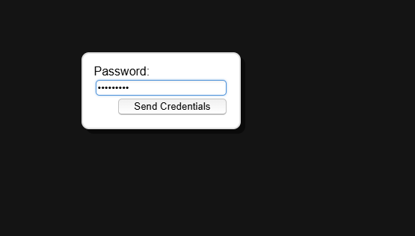
task14_vnc_desktop.png
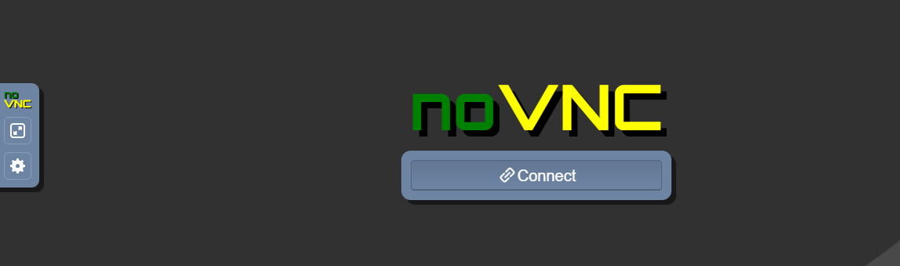

task14_vnc_connect.png


task14_stop_run.png
